Physics Final Exam Review Key
Use this REVIEW SHEET and the notes in the NOTEBOOK TAB ON THE WEBSITE to prepare for your exam.

Newton’s Laws
1st Law | 2nd Law | 3rd Law
An object in motion/at rest will stay in motion/at rest unless acted on by another force. | The force acting on an object is equal to its mass times acceleration. | For every action there is an equal and opposite reaction.

Potential and Kinetic Energy
Potential Energy | Kinetic Energy
Definition: Stored energy that COULD do work. | Definition: Energy that DOES work.
Chemical Potential Energy | Mechanical
Energy that will be released during a chemical reaction. | Energy of motion.
Examples: Food, battery, Gasoline
 | Sound
Gravitational Potential Energy | Movement of energy through waves by vibrations.
Energy because of its position
Examples: Rock at top of hill, Bowstring pulled back. | Heat
 | Movement of energy through particles.

Energy Types
Energy Type | Definition | Examples (2)
Mechanical | Transfer of energy through motion. | Windmill, roller coaster
Kinetic | Energy that DOES work. | Wind, running water
Potential | Stored energy the COULD do work. | Gasoline, sled at top of hill
Nuclear | Energy that is released from a nuclear reaction. | Atom splitting, radioactive decay
Electrical | Energy found in the current of electrons. | Lamp, lightening
Heat/Thermal | Transfer of energy through particles. Measured by temperature. | Fire, steam
Chemical | Stored energy in any type of fuel source. | Food, batteries
Light | Energy from the sun or any luminous object. | Sun, x-rays
Sound | Transfer of energy through vibrations. | Radio, thunder

Energy Transfer
You need to be able to identify the transfer of energy from one source to another.
Blow Dryer | Energy transfers from | Electrical | to | Heat
Apple Tree | Energy transfers from | Light | to | Chemical
Guitar | Energy transfers from | Mechanical | to | Sound
Car Engine | Energy transfers from | Chemical | to | Mechanical
Light Bulb | Energy transfers from | Electrical | to | Light
Solar Panel | Energy transfers from | Light | to | Electrical

Waves
Vocabulary Word | Definition
Amplitude | How high a wave is from the resting point.
Crest | The highest point on a wave.
Trough | The lowest point on a wave.
Wavelength | The distance between corresponding points on 2 consecutive waves.
Frequency | How many waves there are in a certain amount of time.
Medium | The substance that the wave travels through.
Transverse Wave | Wave particles move up and down (perpendicular) to the direction of motion.
Longitudinal Wave | Wave particles move back and forth(parallel) to the direction of motion.
Compression | When the particles are close together in a longitudinal wave.
Rarefaction | When the particles are far apart in a longitudinal wave.

Label the parts of each wave.
Compression
Wavelength
Crest
Wavelength
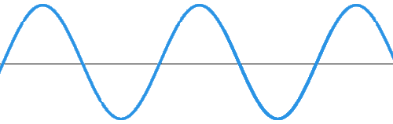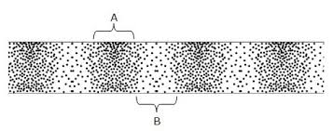
Label the parts of each wave.

Amplitude
Trough
Rarefaction

______Longitudinal_______ Wave
_______Transverse_______ Wave

Pitch and Loudness
The higher the PITCH, the higher the frequency.
The LOUDER the sound, the higher the amplitude.

Analog vs. Digital Signals
Analog |  | Digital
Continuous electric pulses of varying amplitudes | Definition | Translates information into binary format with two distinct amplitudes. ( 0 or 1 )
Continuous | Signal | Individual bits of information
Sine or transverse | Wave Type | Square waves
Records, cassette tapes, speech | Examples | CD’s, DVD’s, Digital devices
Records AS IS | Technology | Converts analog waves to binary format
CAN be affected by noise during transmission | Response to Noise | Noise immune
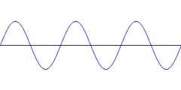 | Picture | 1  0  0

